**User Interface (Silver-Meal Heuristic)**

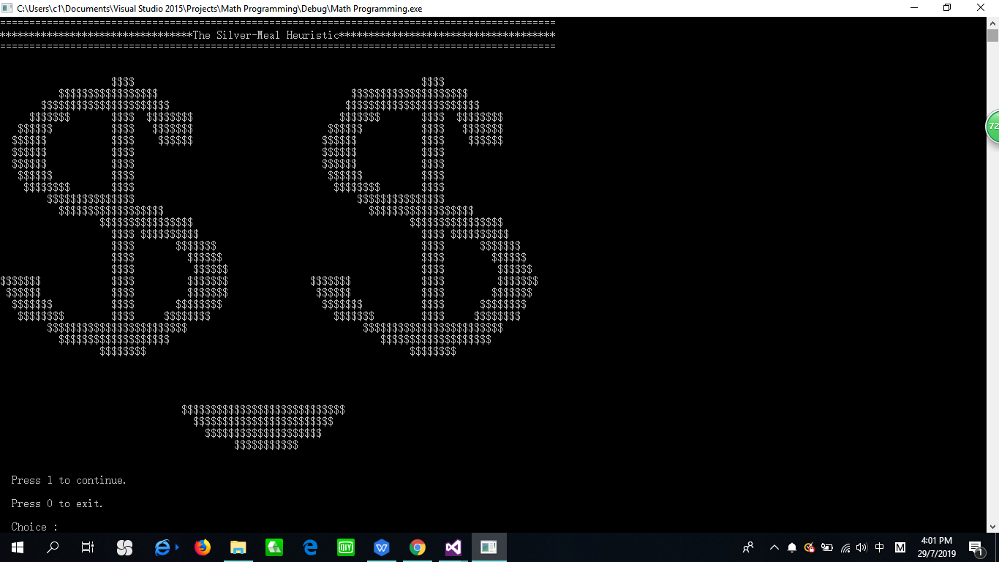

First of all, a welcoming page of Silver-Meal Heuristic programming is displayed with the title "The Silver-Meal Heuristic" as well as a smiling face formed by two dollars symbol. The user is required to press 1 to continue or press 0 to exit the program.

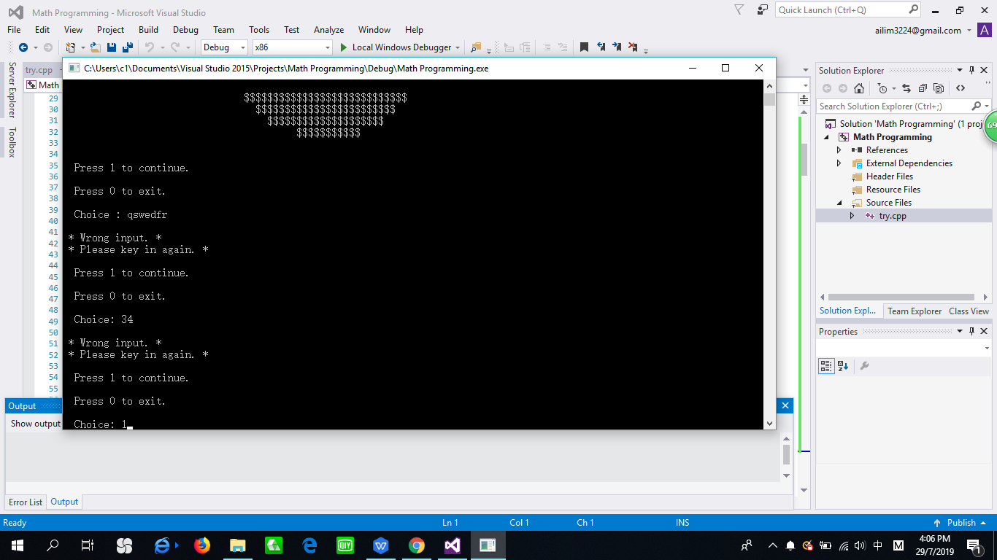

The system requires the user to enter again the input if it is not ‘1' or ‘0' until the required input is obtained. If the user enters ‘1', the program will ask the user to key in the number of duration (month). The program will exit once the user press ‘0'.

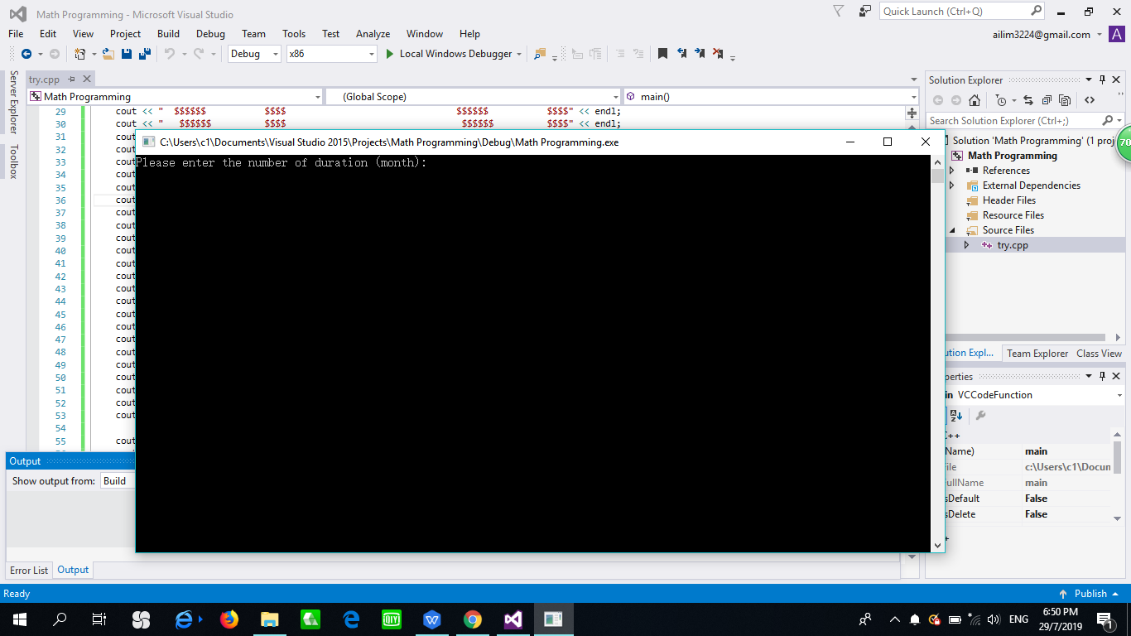

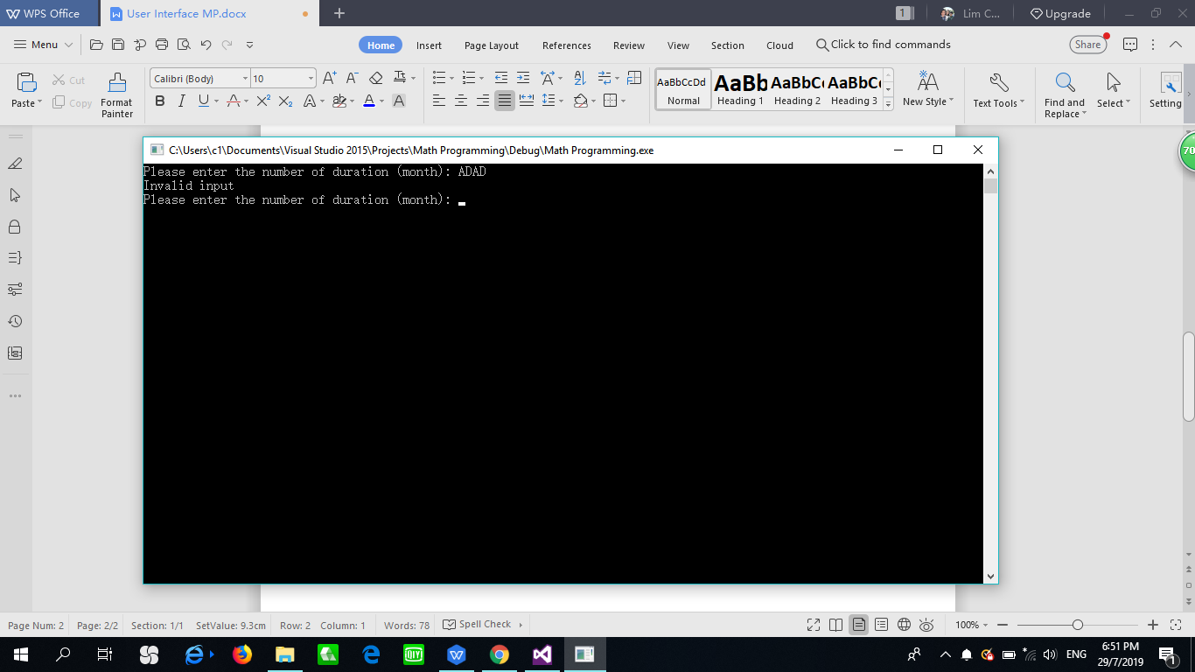

Next, the program will prompt and get the number of duration that the user wants to solve. If the input that the user key in is not an integer, then the program will prompt again until the user key in correctly.

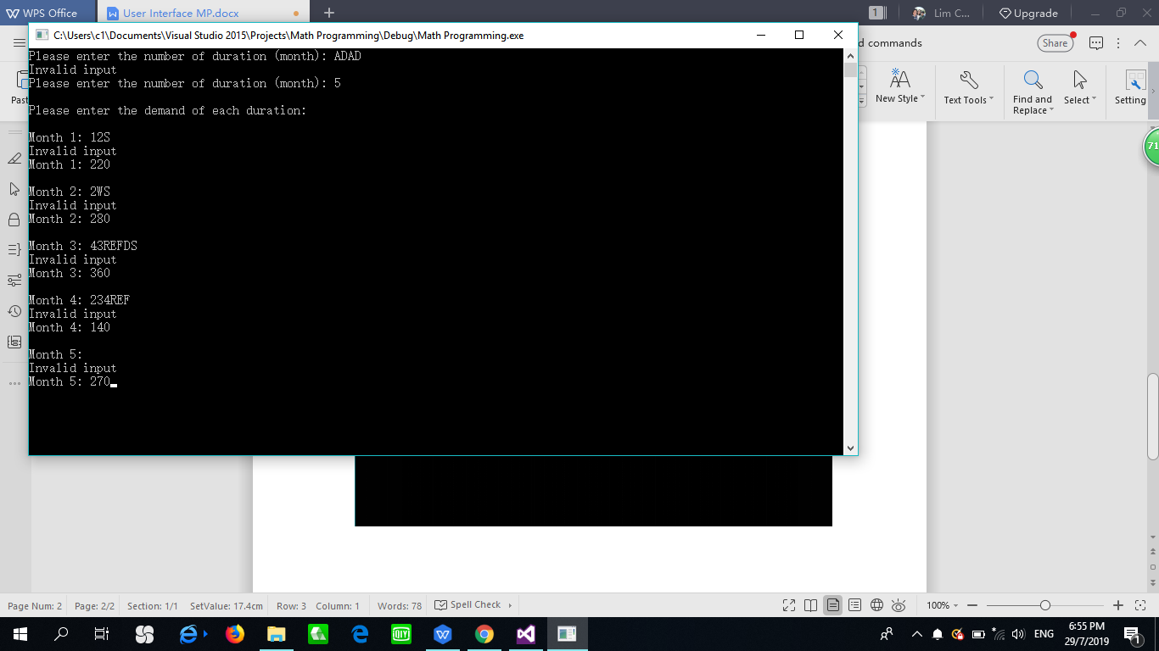

If the user key in 5 for the number of duration, this means that the user needs to enter the demand for 5 months. The demand that the user key in must be an integer. If the user press alphabet, symbol or enter key, the program will ask the user to key in again until the user key in correctly.

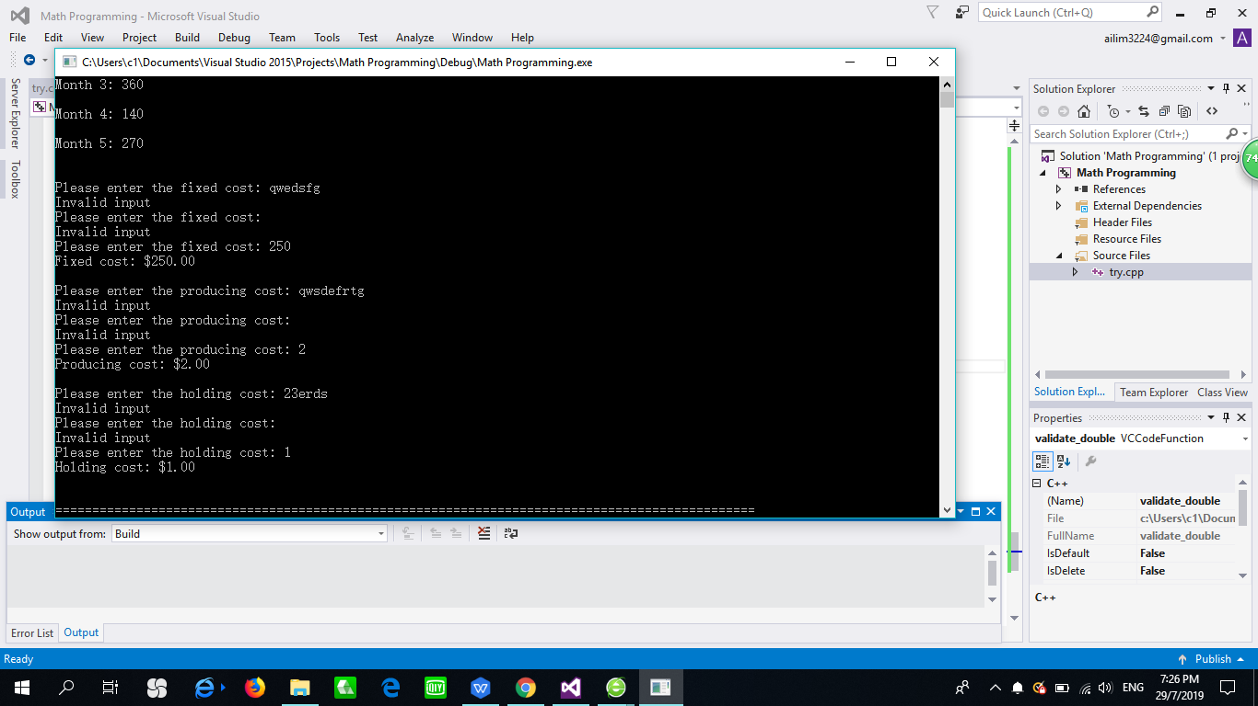

After entering all the demand for each duration, the user is required to enter the fixed cost, producing cost, and holding cost to solve the problem. The cost that the user entered will be displayed in 2 decimal places. If the user press alphabet, symbol or enter key, the program will ask the user to key in again until the user key in correctly.

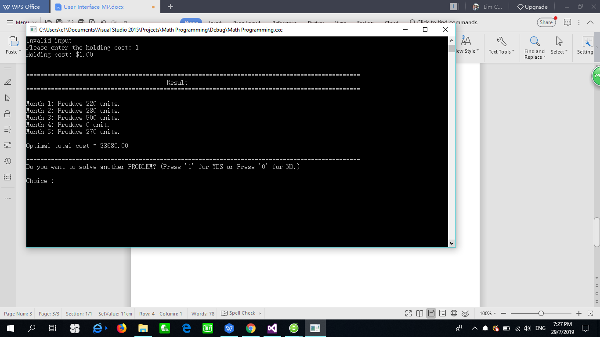

The result is displayed and the user will know about how many productions they need to produce for each duration(month). The optimal total cost will also be displayed on the screen.

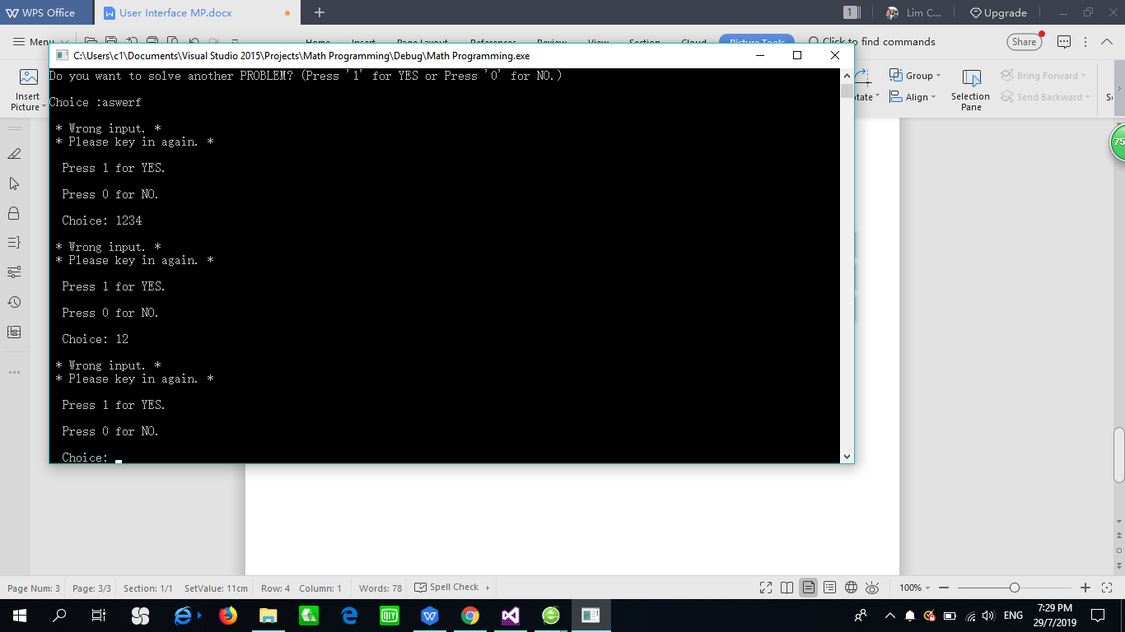

At the end of the program, the program will ask again whether the user wants to solve another problem or not. If the user press ‘1', then the program will prompt and get the number of duration, the demand of each duration, fixed cost, producing cost and holding cost from the user. The program will exit once the user press ‘0'. The user is required to key in again if the user enters the number other than ‘0' and ‘1'.